**RECOMMENDED INSIGHTS – ATLIQ MART**

**AtliQ Mart** has **50** stores in **10** South Indian cities. These stores had two promotional campaigns for **Diwali 2023** and **Sankranti 2024**. I am analyzing the data of these 2 campaigns to make informed decisions in the future.

**STORE PERFORMANCE**

To analyze the performance of stores I have taken a table that shows revenue and quantity sold before and after promotions.

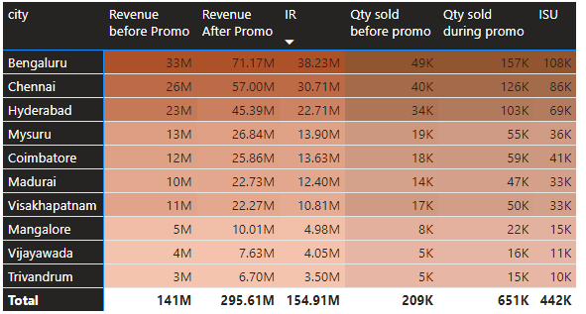

**Increment Revenue(IR)** and **Increment Sold Units(ISU)** are the two main metrics I used to compare the performance of each store.

**Bengaluru**, **Chennai**, and **Hyderabad** are the **top-performing cities** in terms of both metrics. It can be accounted to more number of stores and urban population of Tier 1 cities.

**Mysuru, Coimbatore, Madurai and Visakhapatnam** are **medium-performing cities** with more than 10 Million IR. **Mangalore Vijayawada and Trivandrum** generated IR below 5M making them **low-performing cities.** There is a need for customer acquisition in these regions and to improve the store facilities at these places to make a greater impact from such promotions.

Now comparing the performance of stores in each city I observed that all stores in **medium and low performing cities have comparable metrics**. The variance between them is minimal. But in **top performing cities 1 or 2 stores doesn’t perform well** compared to other stores in the city.

Tier 2 & Tier 3 cities

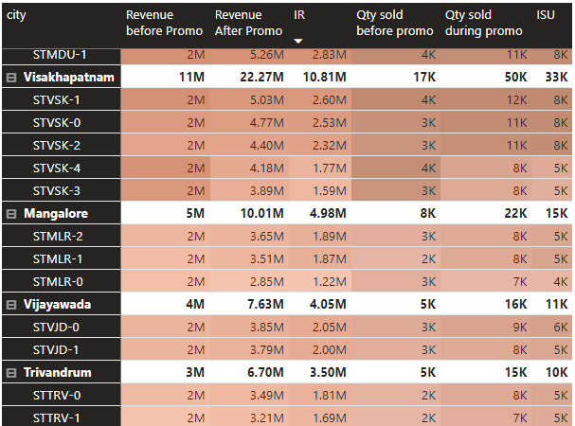

Tier 1 cities

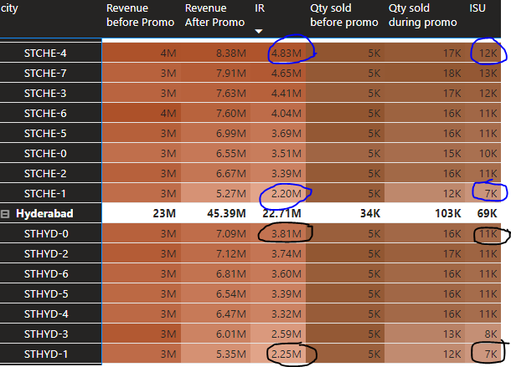

STCHE-1 store in Chennai have less than half of the IR made by STCHE-4

Identified Top and bottom stores in terms of IR and ISU.

|  |  |
| --- | --- |
| Top 10 Stores in terms of IR | Top 10 Stores in terms of ISU |
| Bottom 10 Stores in terms of IR | Bottom 10 Stores in terms of ISU |

Based on these observations, here are some recommendations for future actions:

1. **Focus on Top Performing Cities**:

Continue to invest resources and efforts in Bengaluru, Chennai, and Hyderabad due to their strong performance. Identify and address any issues affecting the underperforming stores in these cities to optimize overall performance.

**2. Improvement Strategies for Medium and Low Performers:**

* **Customer acquisition:** Implement targeted marketing campaigns to attract new customers in Mangalore, Vijayawada, and Trivandrum.
* **Store improvement:** Consider renovations or remodels for these stores to enhance the shopping experience and attract more customers.
* **Product mix optimization:** Analyze local buying patterns and adjust product offerings to better cater to local preferences in these cities.

**3. Addressing Underperforming Stores in Top Cities:**

* **Investigate individual store data:** Analyze sales data, customer demographics, and local competition around underperforming stores in Bengaluru, Chennai, and Hyderabad to identify potential causes for lower performance.
* **Targeted interventions:** Develop specific strategies for each underperforming store based on the identified reasons. This could involve:
  + **New store support:** Implement additional marketing or promotional activities for newer stores to help them gain traction.
  + **Space optimization:** Consider rearranging store layout or utilizing space more effectively to improve customer flow and product visibility.
* **Benchmarking:** Compare underperforming stores with top-performing stores in the same city to identify areas for improvement, such as staffing, promotional strategies, or product assortment.

**PROMOTION TYPE ANALYSIS**

**Five types** of promotions were featured. 3 of them were **discount-based - 25%, 33% and 50%**. **Buy one get one free (BOGOF) and 500 cashback** were the other 2 promotion types.

* **500 cashback**

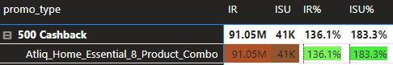

Only one product - **Atliq_Home_Essential_8_Product_Combo from combo1 category** was featured in this promotional type. The product was sold at Rs. 2500 during the promotions by deducting Rs. 500 from its base price. The revenue from this one product with 500 cashback offer is the **major contributor** to the whole **IR**. (i.e 58.78% ) **91.05 M** more revenue was generated by this promo type when compared to their previous weeks.

* **Buy One Get One Free(BOGOF)**

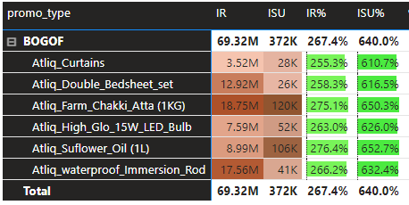

**6 products from 3 categories** were featured in this promo type. **372K** units sold in BOGOF make up **84.30%** of the **total ISU** from campaigns.

|  |  |
| --- | --- |
| Categorical contribution to IR – BOGOF | Categorical contribution to ISU – BOGOF |

Grocery and Staples category products have **lower base prices** than the Home care or Home Appliances categories. Hence **IR** generated by grocery and staples category products are **lesser** than other categories in this promo type **even though the units sold are higher** in number.

* **50% OFF**

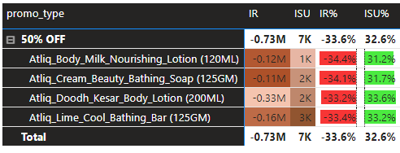

**4 products from personal care category** was featured in this promo type. All these products have **base price less than Rs. 200**. Even though more units were sold compared to the previous weeks (**ISU is 7K**) the revenue wasn't incremented. The **revenue after promotion was 0.73 M less than the revenue before promotion** due the discounted price. Hence the percentage change in revenue turned to be negative and percentage change in sold units turned to be positive.

* **33% OFF**

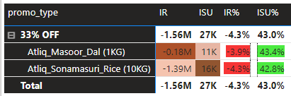

**2 products from Grocery & staples** category are featured in this promo type. Masoor Dal base price is less than Rs. 200 and Sonamasuri Rice have base price Rs. 860. **More units were sold during the promotions** compared to their previous weeks and have positive ISU. But there is a direct revenue loss on each purchase due to the discounted price. Hence the **revenue generated during promotion is less** than the revenue generated before promotion.

* **25% OFF**

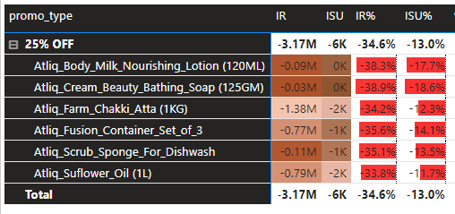

**6 products from 3 categories** were featured in this promo type. 4 products have base price less than Rs. 200. Only 2 products have nominal ISU. Rest of the products were not sold well despite promotions. This is the **promotion type with both negative ISU and IR**.

From these observations I understand that **BOGOF and 500 cashback performed better than discount based promotions**. **Even without revenue gain, 50% off and 33% off discounts boosted sales volume (units sold)** **and reduced inventory**, leading to:

* Lower storage costs.
* Mitigated risk of obsolescence and spoilage.
* Potential for introducing new products.

Identified Top and bottom 2 promo types in terms of IR and ISU.

|  |  |
| --- | --- |
| Top 2 promo types in terms of IR | Top 2 promo types in terms of ISU |
| Bottom 2 promo types in terms of IR | Bottom 2 promo types in terms of ISU |

Contribution of each promo type to Increment Revenue (IR)

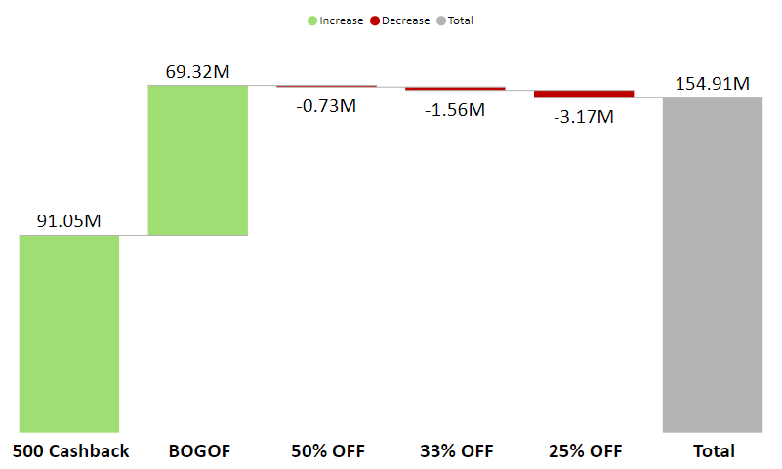

Contribution of each promo type to Incremental Sold Units (ISU)

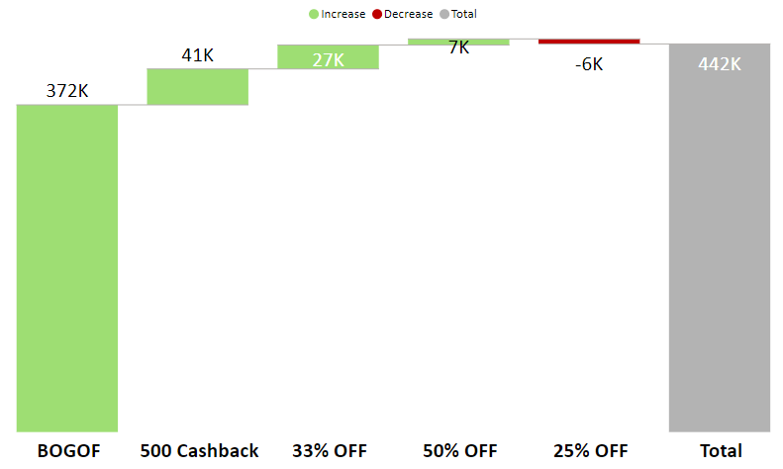

**Comparing the** **revenue loss/leak** due to promotion for BOGOF and 500 Cashback, it is noted that revenue leak for **500 Cashback** is much lower than the revenue leak of BOGOF. Only Rs. 500 is lost per unit in cashback offer. Since the base price is RS.3000 – **16.67% of base price is lost/leaked per unit**. On the other hand in **BOGOF 50% of the base price is lost/leaked on each unit sold**. So products with high base price 500 Cashback should be the preferred promo type.

Based on these observations, here are some recommendations for future actions:

**1. Leverage Effective Promotions**:

* **Focus on BOGOF and targeted cashback offers**: These promotions have been shown to be effective in driving sales volume (ISU) and increasing revenue (IR) without significantly impacting margins, especially for higher-priced items.
* **Refine discount-based promotions:** For low-priced items, consider alternative strategies like bundling with higher-priced products, offering limited-time discounts, or loyalty programs to stimulate sales without significant revenue loss.

**2. Prioritize Inventory Management:**

* **Utilize clearance sales strategically**: While not directly generating revenue, they can help:
  + Reduce storage costs.
  + Mitigate the risk of obsolescence and spoilage.
  + Create space for introducing new products.

**3. Segment Promotions based on Price and Category:**

* Implement cashback offers for higher-priced items to incentivize purchases without significantly impacting margins.
* Offer limited discounts (e.g., 10-15%) on low-priced items to stimulate sales without significant revenue loss.
* Consider bundling low-priced items with higher-priced ones to create perceived value and increase overall margin.

**PRODUCTS AND CATEGORIES ANALYSIS**

There are 15 products from 5 categories and their distribution is as below.

Number of products by category

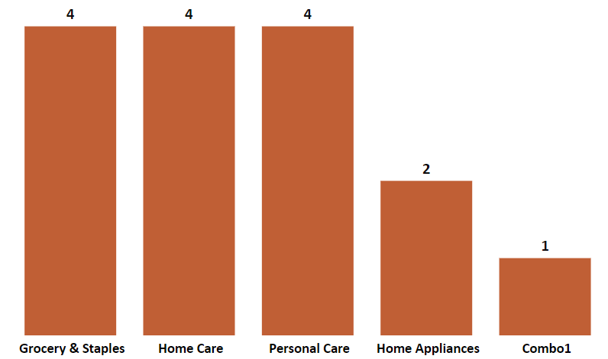

Let us see the categorical contribution to Incremental Revenue.

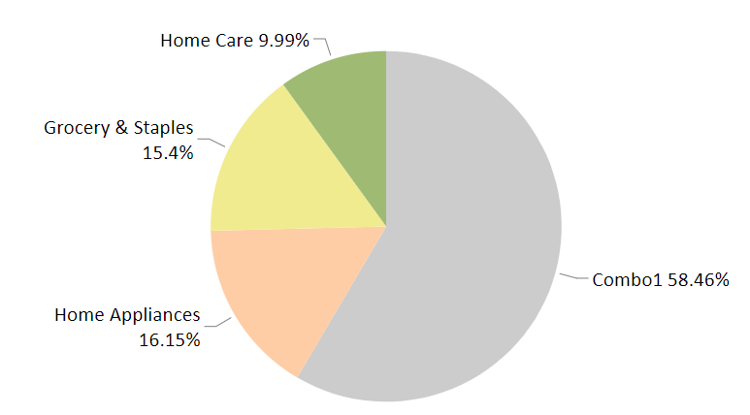

Creating a product by **bundling 8 essential home product** have been a **remarkable strategy** of these campaigns. The base price of this product is Rs. 3000 and was featured in **500 cashback** offer. This product and combo1 category has contributed **58.46% of total IR.**

**Personal Care category could not make any mark** in these campaigns. Products from this category was featured in 25% OFF and 50% OFF. More units were sold only in 50% OFF promo type and all other metric performance is negative for this category as shown below.

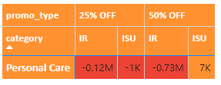

Different strategies of promotion need to be tried in this category such as

* Limited-time offers, such as flash sales or weekend deals, can create a sense of urgency and encourage customers to make quick purchasing decisions
* Offer limited discounts (e.g., 10-15%) on low-priced items to stimulate sales without significant revenue loss.
* Placing promotional personal care products near check-out points drives impulse purchases, increases visibility, enhances convenience, and boosts overall sales

Categorical contribution to ISU

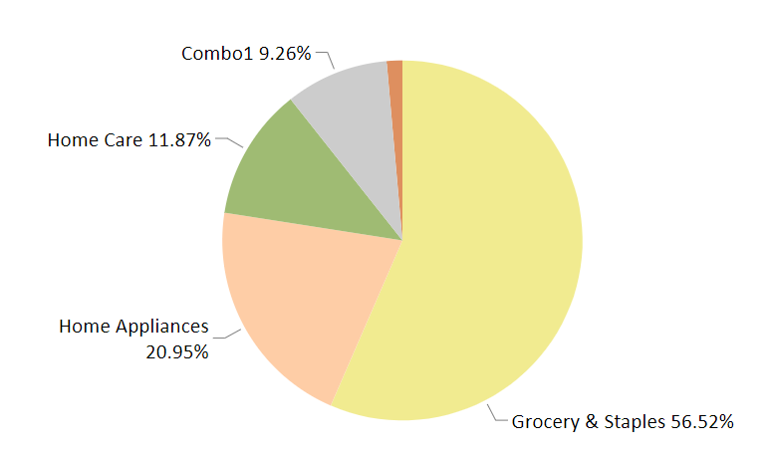

The sales volume of **Grocery & Staples** have shown a steady increase and it contributes to **56.52% of the total ISU** followed by Home Appliances (20.95%) , Home care (11.87%) and Combo1(9.26%). The contribution of Personal care category to the ISU is nominal 1.4%

IR of each category in Rupees

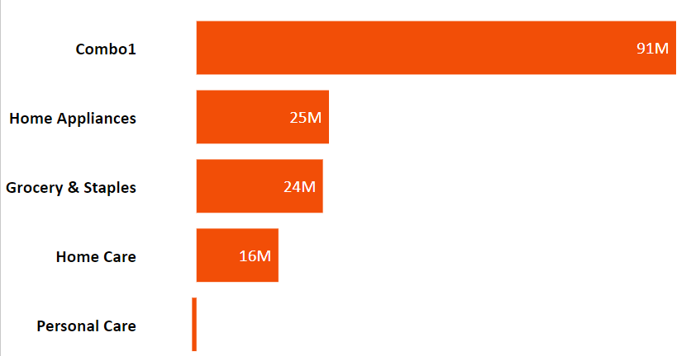

ISU of each category

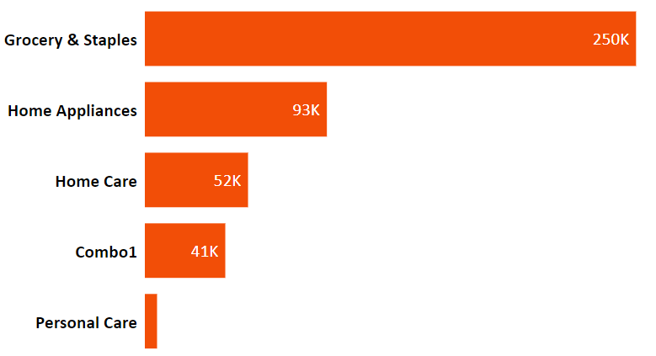

To get another perspective I **divided the products into 3 groups according to the base price** as below.

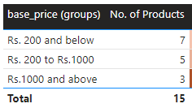

|  |  |
| --- | --- |
| Increment Revenue contribution by  Base price groups | Increment Sold Units contribution by  Base price groups |

**75.61% of ISU** are price **below Rs. 1000**. And **78.**46% of IR is from products sold from base price group – **Rs.1000 and Above**.

* Top of Form
* **Strategic Pricing Adjustments for Promotional Categories**

**Base price of four products** shown below have been **slightly raised when featured on BOGOF or 50% OFF category**.

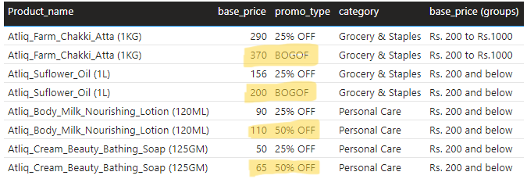

Let us take the case of bathing soap here. If the **base price was Rs.50 itself** for the 50% OFF. We will be giving away 2 soaps for Rs. 50. So the **unit cost is 25** by **incurring Rs. 25 revenue leak.**

Since it is featured with increased base price, 2 soaps are given away for Rs. 65. So the **unit cost is Rs.32.5** by **incurring Rs. 17.5 revenue leak.**

This approach **mitigated potential revenue loss** by balancing discounted prices with slight increases, ensuring effective promotion execution while **maintaining overall profitability**.

**IR% and ISU%** are two other metrics used to provide insights into the effectiveness of promotions by quantifying the **percentage increase** in revenue and sold units compared to pre-promotion levels.

IR % is (Increment revenue / revenue before promotion)*100

ISU% is (Increment sold units/ revenue before promotion)*100

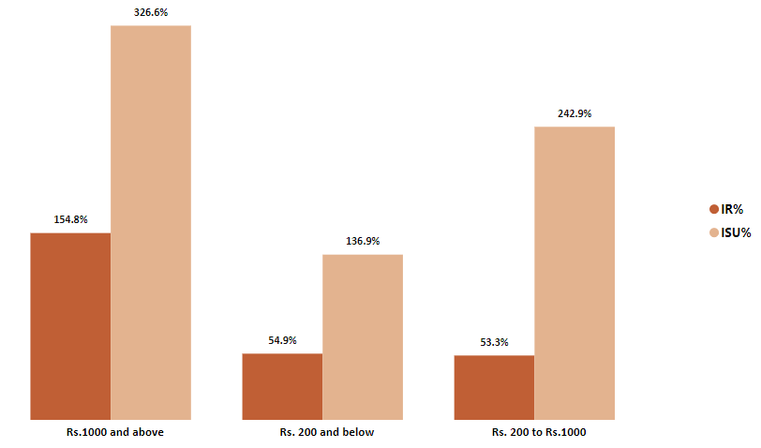

IR% and ISU% by base price groups

I can see a clear trend: **higher-priced products experience a significantly greater sales lift** during promotions. Products priced at Rs. 1,000 and above exhibit the highest Increase in Sales Units **(ISU%) at 326.6%**. Conversely, **products priced at Rs. 200 and below** show **the lowest ISU% (136.9%),** indicating that these items are **frequently purchased even without promotions**, resulting in a lower percentage change.

This trend extends to **revenue (IR%)**, with the highest increase observed for the Rs. 1,000 and above price group (154.8%).

IR% and ISU% by category

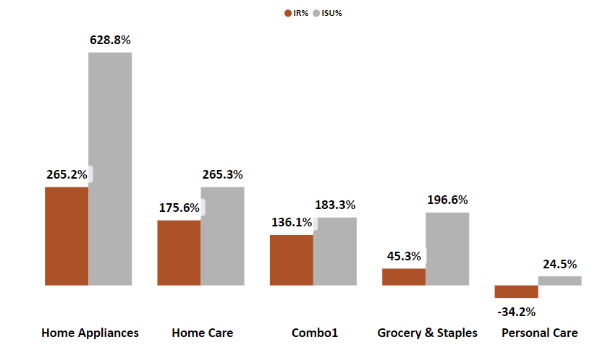

**Home Appliances and Home Care categories** witnessed the **highest sales lift (ISU%)** during promotions. This indicates a consumer preference for purchasing these **non-essential items** at **discounted prices**

In contrast, **Grocery and Personal Care categories**, consisting of **everyday essentials**, showed **lower sales lift** during promotions. This suggests that consumers **purchase these products consistently,** regardless of promotions.

Identifying top and bottom 5 products in terms of all 4 metrics.

|  |  |
| --- | --- |
| Top 5 products in terms of IR | Bottom 5 products in terms of IR |
| Top 5 products in terms of ISU | Bottom 5 products in terms of ISU |
| Top 5 products in terms of IR% | Bottom 5 products in terms of IR% |
| Top 5 products in terms of ISU% | Bottom 5 products in terms of ISU% |

**Only 2 products were sold lesser during promotion** than their previous weeks – means with **negative ISU**. They are **Atliq Scrub Sponge for dishwash and Atliq fusion container set of 3**.

**DIWALI SALES CAMPAIGN Vs. SANKRANTI SALES CAMPAIGN**

Let us now compare the two campaigns and find out its performance. All 15 products were featured in both sales. Few products were in the same promo type for both the campaigns, while others in different promo types for Diwali and Sankranti sales.

|  |  |
| --- | --- |
| IR | ISU |

Diwali sales have more Increment Revenue than Sankantri sales, but more units were sold in Sanktanti sales when compared to Diwali sales. To understand this further let us look into performance of base price groups during both sales campaign.

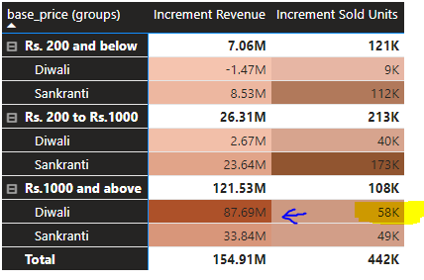

During Sankranti sales, the first two base price groups exhibit higher Incremental Sold Units (ISU), while for products priced **Rs. 1000 and above, ISU is higher during Diwali sales**. This shift in ISU distribution contributes to **higher IR during Diwali**, as products priced Rs. 1000 and above drive revenue growth.

Comparing the category wise performance of both campaigns.

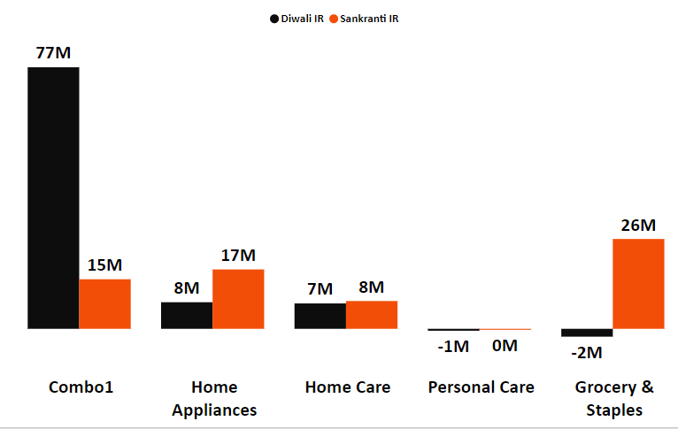

IR in Diwali and Sankranti Campaigns

It is now clear that **the sale of combo1 product** - Atliq Home Essential 8 Product Combo -which has base price Rs. 3000 **resulted in more IR in Diwali** campaign than the Sankranti Campaign.

This combo1 deal performed very differently during the Diwali sales than the Sankranti sales. We can see a great difference in IR generated in both campaigns. **Why did the product under perform during Sankranti sales**??

More information about the 8 products are not being provided. I assume that it may be some cleaning accessories and products. There is only 3 months gap between these 2 campaigns. So the **diwali buyers of this product would still have it in stock and did not buy it again**. **34K units were sold during Diwali and only 7K units were sold during Sankranti** sales.

Moving to Home Appliances category 2 products – **Atliq High glow LED Bulb and Atliq waterproof immersion rod did better in Sankranti sales** which was featured in BOGOF. Maybe in the **chill weather of January** customers bought the immersion rod to boil water.

ISU in Diwali and Sankranti sales campaign

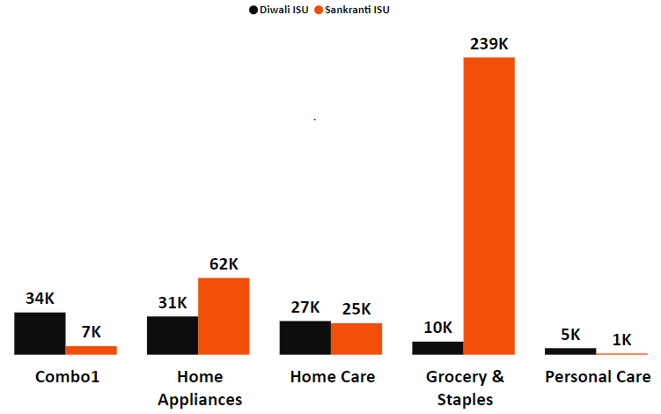

The **Grocery & Staples category** experienced a remarkable **2290% increase in sales volume (ISU%)** during the Sankranti sales compared to Diwali, with sales skyrocketing from **10K units to 239K units.** This significant growth can be attributed to a strategic shift in promotional tactics.

* **Shifting Gears: From Discounts to BOGOF:**

During the Diwali sales, products in this category were offered a **25% discount**. In the Sankranti sales, however, this approach was replaced with a **BOGOF (Buy One Get One Free) promotion**, which effectively increased the quantity of products purchased. This **change in promotional strategy** not only **boosted sales volume (ISU%)** but also **generated revenue (IR) of Rs. 26 million**, representing a **1400% increase** compared to the Diwali sales, where no revenue increase was observed.

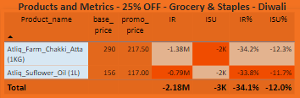

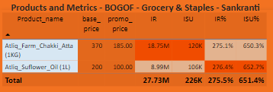

**Switching the promo to BOGOF was a genius move - it cleared the shelves and brought in the cash!**

**Diwali and Sankranti Sales: Success Beyond Revenue**

While **incremental revenue (IR) is a crucial metric**, it's crucial to remember that **success doesn't solely depend on immediate revenue gains.** **Diwali and Sankranti sales exemplify this perfectly, demonstrating success in distinct ways:**

**Diwali Sales:**

* **Focused on promoting higher-priced items:** This strategy, even with a smaller sales volume increase, could contribute significantly to revenue due to higher profit margins.
* **Targeted campaigns:** Diwali, being a major festival, might encourage consumers to splurge, leading to higher sales in the Rs. 1,000+ price group.

**Sankranti Sales:**

* **Effective inventory management:** Shifting the promotion for Grocery & Staples from discounts to BOGOF successfully cleared stock while generating positive revenue.
* **Increased sales volume (ISU%):** The Sankranti sales saw a significant surge in sales volume, particularly for lower-priced products, potentially indicating higher demand during this period.

These examples highlight the importance of **understanding the broader impact of promotional campaigns**. Focusing solely on revenue growth might miss the **positive contributions to inventory management, brand awareness, and customer engagement**, which ultimately pave the way for **long-term business success.**

In conclusion, both Diwali and Sankranti sales achieved success by **strategically addressing different business objectives**, demonstrating the importance of **looking beyond immediate revenue figures** to evaluate the **comprehensive impact of promotional campaigns.**